AI-Assisted Master Prompt Generation. Challenges and Proposed Solutions
The problem that I will address is:
When developers use AI coding agents over many prompts, after their developing process is done, they want to consolidate the entire prompt history into one master prompt at the end of the project to hand it over to a different person or AI model. As a result, they ask an AI agent to perform this consolidation which does not reliably return the original intent. Instead, the agent tends to presents its own implementation choices such as design pattern, specific filenames, or extra features as if they were user requirements.
Although modern AI coding agents can consolidate relatively short prompt histories when provided with carefully engineered instructions, it remains unclear whether these methods preserve requirement traceability and scale to realistic software development sessions. This thesis proposes a traceability-constrained prompt consolidation pipeline that separates user intent from implementation artifacts and evaluates its effectiveness across multiple AI coding agents.

Related Works
These papers are what I have read in the last few days to firstly figure out that these problems existed from the previous research. Secondly,

Most related in idea
- Enhancing User Interaction in ChatGPT: Characterizing and Consolidating Multiple Prompts for Issue Resolution — Mondal, Bappon & Roy, 2024. Closest existing work on “consolidating multiple prompts,” but its goal is to make a single prompt to be more efficient by trying to fix the gap of prompt by consolidating them
- Handoff Debt: The Rediscovery Cost When Coding Agents Take Over Interrupted Tasks — 2026. Closest framing for agent-to-agent handoff, but in mid-task rather than at the end of project
- Contextual Memory Virtualisation: DAG-Based State Management and Structurally Lossless Trimming for LLM Agents — 2026. Alternative solution shape: a live queryable memory store rather than one static portable prompt
These 3 tried the same idea as try to make a single prompt, or try to handoff the project to any other agent using prompt. But it still not our problem

Prompt Loss Definition
- Survey of Hallucination in Natural Language Generation — Ji, Lee, Frieske, Yu, Su, Xu, Ishii, Bang, Madotto & Fung, ACM Computing Surveys 2023. Defines extrinsic / input-conflicting hallucination —it was called as the named extrinsic hallucination
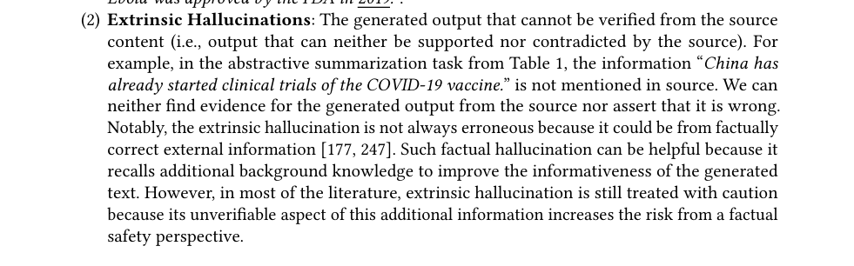
From: survey of hallucination in natural language generation

Evaluate the prompt similarity and code traceability
- RECOVER: Toward Requirements Generation from Stakeholders' Conversations — 2024. Extraction methodology this thesis's pipeline adapts for pulling requirements out of dialogue
- Evaluating the Use of LLMs for Documentation to Code Traceability — Alor, Khatoonabadi & Shihab, Concordia University, 2025. Precision/Recall/F1 traceability evaluation

Suggested Solution
- Spec-Driven Development:From Code to Contract in the Age of AI Coding Assistants – 2026. Exactly my idea to separate, this paper is about separate the specifications from the code, treat it as the first artifact and then the code will be generated from it
Also in this paper, it was a mention of challenges that we are facing in my thesis
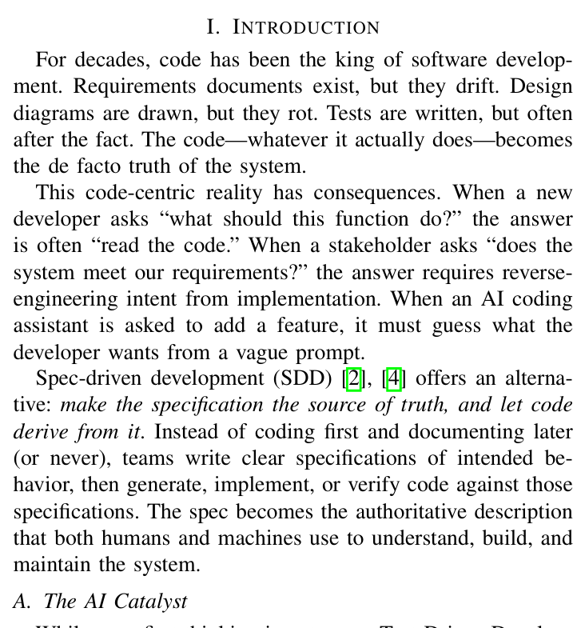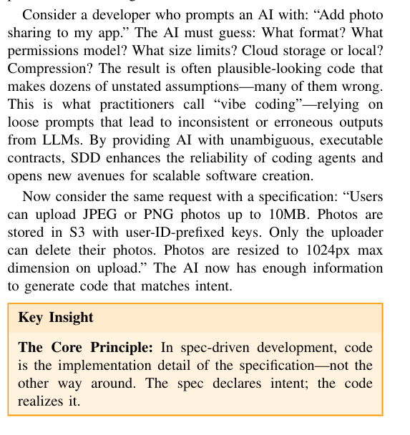
- Contextual Memory Virtualisation: DAG-Based State Management and Structurally Lossless Trimming for LLM Agents — 2026. A memory that store state of the prompt, I can use this idea if storing prompt but keeping track of it mid progress
- Reverse Prompt Engineering - Li, Klabjan 2025. A solution to turn output back to prompt using algorithm without input prompt. Like a prediction of promt when you lost them
- After read these papers, I think that the reserve prompt engineer is more likely not the case for my thesis to use because we already have and still keep the prompts.
- I believe that we should separate the specs from the implemented code to keep the intent of user prompts clean. Also, to keep those specifications clean and not touch by claude, the second paper proposed a structured data to keep instead of raw text.

Research Questions
- RQ1 — When an AI agent consolidates a prompt sequence without support, does the result contain non traceable requirement, feature loss, or additional information compare with the original prompt?
- RQ2 — Does the method of splitting between prompts and code help AI agent improve in consolidating the final master prompt?
- RQ3 — Does a master prompt produced by this pipeline let a different AI model, or a different person, reproduce a functionally equivalent outcome to the original project?

Design of Experiment
Dataset:
- My own synthesis examples based on difficulty and the length of prompt:
Run on 3 agents, Antigravity Gemini Flash 3.5, Codex GPT 5.5, Claude Sonnet 4.6
So for this part I think only give example like we did before is just to illustrate the problem, so that we have to conduct experiment between these models (which I owned api key so that I can do it right away)
I can make prompts for 1 simple project (around 10- 15 prompts) and 1 hard project (30+ prompts):
Before the project I will give them this a pre-experiment prompt (show in the last page)

For each project (simple and hard), I will do 3 runs:
The prompt will be decided before run the test, before the start, I make sure that the folder was separated from each other models. I will consolidate the prompt as the ground truth for this testing evaluation => This is the master prompt 1 which is the best matching of the original prompt
- 1st run: I feed the prompts to the agent one by one, like a real coding session, until the project is done. And leave it as it is to preserve original prompts with original code
- 2nd run: This second run is also like the 1st run but at the end, I will ask Agent to consolidate a master prompt => got master prompt 2
- 3rd run: my own method. I take the same prompt history and the same final code, but this time I split the work into two parts: first I get an agent to pull out what was actually asked for, looking only at the prompts, without seeing the code. Then I get an agent to look only at the code and describe what it actually does. Then I compare the two lists and combine them into one master prompt, keeping anything that was really asked for and dropping anything the agent just made up on its own. This is my proposed method. => got master prompt 3
- 4rd run: Rebuild the project with 3 master prompts for comparison
- After I got these master prompts I can do the evaluation by measure and calculate metrics

Metrics to Evaluate the master prompt from models
- English Prompt — Textual Fidelity
Automatic metrics:
The idea of evaluating is that to compare between master prompt and ground truth. However, the master prompt contained paraphrasing, reordering, or different words from the ground truth so that if I try to evaluate based on n-gram/token overlap using regular precision, recall, f1, it will be resulted in unreliable evaluation.
Instead, BERTscore matches tokens by contextual-embedding similarity, judging meaning over exact wording.
And how does the contextual-embedding similarity works:
Firstly, the language model has been trained on masked word prediction - the model is repeatedly shown sentences with a word hidden and forced to guess it from the surrounding words over a huge corpus => the pretrained language model could categorize vector representations in similar meaning.
Secondly, 2 sentences will be split into different n tokens using contextual embedding.
This process using tokenizer GPT 2 to split words into sub-words which later be embedded into separate vectors. Each token can generate different vector representations depending on surrounding words (even the same word in different sentence)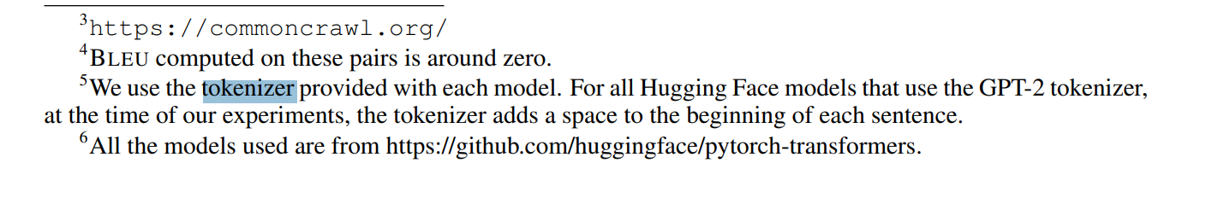
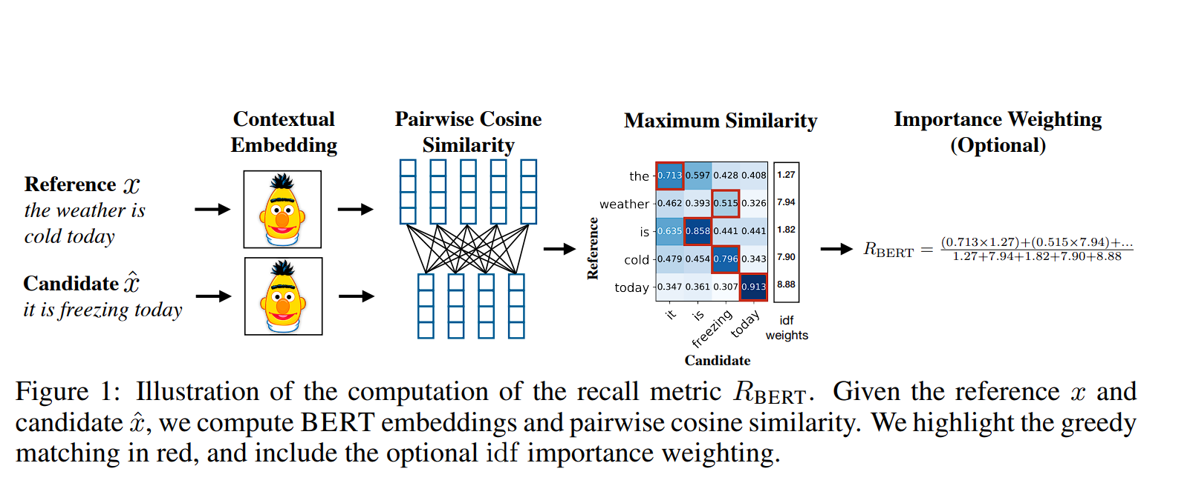
Finally, these vectors representation will be matched with highest cosine similarity vectors using greedy match.
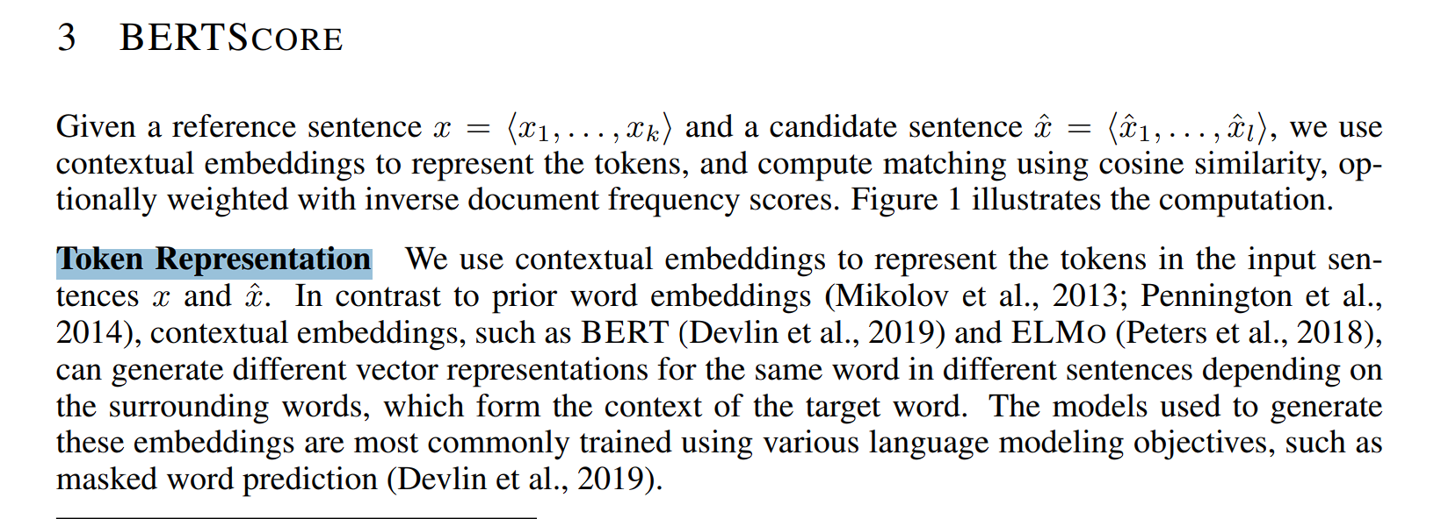
Example: if there are 2 objects:
- ground truth: “the weather is cold today”
- master prompt: “it is freezing today”

BERTScore: measure semantic similarity between the master prompt and the ground truth
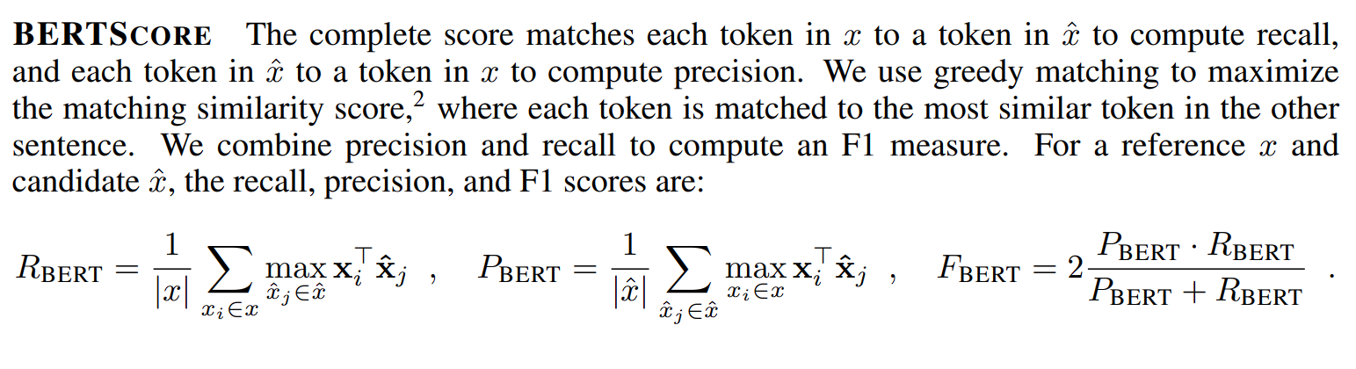

Model use: microsoft/deberta-xlarge-mnli

I use this model following the BERTScore authors' recommendation in github repository of the following paper https://arxiv.org/pdf/1904.09675

AlignScore: swd

Human evaluation: Expert in Software Engineer prof. Garcia Manuel Clavel
- Traceable Information: Decompose master prompt into individual statements; classify each as traceable if it meets the original requirements
- Non-Traceable Information: requirements that didn’t told by original prompts such as: software design pattern, filename,
I adapted this from the paper about FACTscore which also calculate the percentage of fact that can be drawn from an output generated by llm
- Functionality of the Code — Functional Fidelity:
Now if I use the master prompt to rebuilt the product I have to check for
Each feature in the original's checklist is checked against the rebuilt product: Match / Missing / Extra / Modified. Higher is better.
Based on the paper: Evaluating the Use of LLMs for Documentation to Code Traceability
There is also another way to conduct this function test is to make unit test for each requirement and measure the percentage of
passed unit test / total tests

Project easy:
### Prompt 1
Create a portal homepage.

### Prompt 2
Add 3 navigation buttons:
Home, Orders, Contact.

### Prompt 3
If the label of the navigation button starts with “H”, the background color of the button should be blue; if the label of the navigation button starts with “O”, the background color should be red; if the label of navigation button starts with “D”, the background color should be “yellow”.

### Prompt 4
Add dark theme.

### Prompt 5
Remove dark theme.

### Prompt 6
Add sidebar navigation.

### Prompt 7
Undo sidebar.

### Prompt 8
Use top navigation instead.

### Prompt 9
Change navigation buttons:
Dashboard, Policies, History, Contact.

### Prompt 10
Style navigation:
rounded buttons, blue accent, modern font.

### Prompt 11
Add a contact form with name, email, and message fields.
The email field must be validated before the form can submit.

### Prompt 12
Make sure the page also works well on mobile screens.

Project hard:
### Prompt 1

I'd like to build a simple ERP web application for a small business. Let's start with a clean foundation that we can gradually expand.

---

### Prompt 2

The first thing we need is customer management. Users should be able to create, edit, delete, and browse customers.

---

### Prompt 3

Now let's add products. Each product should have a name, SKU, price, and current stock quantity.

---

### Prompt 4

We'll probably need navigation now. A sidebar on the left with Dashboard, Customers, and Products should be enough for now.

---

### Prompt 5

The dashboard doesn't need much yet. Just show the total number of customers and products.

---

### Prompt 6

Let's start implementing sales orders. A sales order should belong to one customer and contain one or more products with quantities.

---

### Prompt 7

I forgot something important. The total amount should be calculated automatically from the selected products and quantities.

---

### Prompt 8

When a sales order is confirmed, reduce the inventory automatically.

---

### Prompt 9

Actually, don't let users confirm the order if any item doesn't have enough stock available.

---

### Prompt 10

I showed the prototype to the client. They don't like the sidebar. Replace it with a top navigation bar instead.

---

### Prompt 11

Now we also need purchase orders so staff can restock inventory.

---

### Prompt 12

When a purchase order is marked as received, increase the product stock automatically.

---

### Prompt 13

Since we're buying from suppliers, let's add vendor management too. It should work similarly to customer management with create, edit, delete, and browse operations.

---

### Prompt 14

The client asked whether inventory could be tracked separately for multiple warehouses. Let's support multiple warehouses.

---

### Prompt 15

Never mind. The client said that's overkill for their business. Let's go back to a single stock quantity for each product.

---

### Prompt 16

Whenever a sales order is confirmed, automatically generate an invoice.

---

### Prompt 17

Invoices should have a due date 30 days after they're created.

---

### Prompt 18

Finance just asked to shorten the payment period. Make the invoice due date 15 days instead.

---

### Prompt 19

Invoices also need a payment status. Use these three statuses: **Unpaid**, **Partially Paid**, and **Paid**.

---

### Prompt 20

Users should be able to record payments against invoices.

---

### Prompt 21

Support these payment methods:

- Cash
- Bank Transfer
- Credit Card

---

### Prompt 22

Scratch that. The company doesn't accept credit cards. Remove that payment option.

---

### Prompt 23

We should probably introduce user roles now. Let's have **Admin** and **Staff**.

---

### Prompt 24

Staff members shouldn't be allowed to delete customers or products. Only Admin users can do that.

---

### Prompt 25

Actually, we need one more role. Add a **Manager** role. Managers should also be able to delete customers and products, but they shouldn't be allowed to manage user accounts.

---

### Prompt 26

The owner wants to know which products are running low. Show low-stock products on the dashboard whenever stock drops below **10**.

---

### Prompt 27

That fixed threshold won't work for every product. Each product should have its own configurable low-stock threshold instead.

---

### Prompt 28

Let's add a monthly sales report showing the total sales for each month.

---

### Prompt 29

A chart would probably make the report easier to understand. Please add one.

---

### Prompt 30

After looking at it, I think the chart is unnecessary. Let's remove it and just keep the monthly sales numbers in a table. It'll be easier to maintain.

---

### Prompt 31

The dashboard feels a little plain. Please make it look clean and professional.

---

### Prompt 32

Once we have a lot of data, those lists are going to get pretty long. Add pagination to all list pages, including customers, products, vendors, sales orders, purchase orders, and invoices.

---

### Prompt 33

Searching would also be useful. Add a search bar so users can quickly find customers and products by name.

---

### Prompt 34

One more thing. Add some basic validation. Product prices and stock quantities should never be allowed to have negative values.

---

### Prompt 35

The codebase is getting a bit difficult to follow. Please clean up the overall structure where appropriate and add comments explaining the main business logic.

---

### Prompt 36

The owner wants to be able to export the monthly sales report so it can be shared with their accountant. Let's add an export feature that generates a CSV file.

---

### Prompt 37

I checked with accounting. They'd actually prefer an Excel (.xlsx) file instead of CSV.

---

### Prompt 38

Some departments still want CSV while accounting wants Excel. Let's support both export formats.

---

### Prompt 39

After discussing maintenance costs, we've decided to simplify things. Remove the CSV export and keep only Excel (.xlsx).

---

### Prompt 40

The monthly sales report is becoming harder to use as more data is added. Please let users filter the report by a custom date range.

---

### Prompt 41

There's another permission requirement. Staff members should only be able to view reports that they created themselves. Managers and Admins can continue viewing all reports.

---

### Prompt 42

One of the users accidentally deleted several vendors yesterday. Instead of permanently deleting vendors, move them to a recycle bin so they can be restored later.

---

### Prompt 43

After reviewing our data retention policy, only vendors should use the recycle bin. Customers and products should continue using permanent deletion based on the user's permissions.

---

### Prompt 44

The owner asked whether we could keep a history of important business events. Please add an audit log whenever a sales order is confirmed, an invoice is generated, or a payment is recorded.

---

### Prompt 45

The audit log should also record which user performed the action and the exact date and time it happened.

Pre-Experiment Prompt:
The following instructions are only for setting up our conversation. They are **not** part of the software project's requirements and **must not** be included if you are later asked to summarize, consolidate, or generate a master prompt for the project.

Throughout this conversation, treat every subsequent request as part of the same software project. Only work within the current project folder and do not create a new project or switch to another workspace unless I explicitly ask you to.

Acknowledge these instructions and wait for the first project prompt.

Report 10/07/2026

BERTScore - semantic similarity (secondary)
BERTScore splits each text into subword tokens (a token is a subword, not a whole word), embeds each into a contextual vector, and greedy-matches tokens by cosine similarity between vectors, so it credits paraphrase and ignores word order. which the BERTScore paper reports as the strongest backbone for English. Two limitations make it secondary: (1) it caps at 512 tokens, so long prompts are truncated and their scores become unreliable; (2) it measures similarity only - it cannot tell a paraphrase from a contradiction.

AlignScore - faithfulness / entailment (primary)
AlignScore is a learned metric, not a similarity formula. It feeds the context and the claim into a RoBERTa model together and predicts whether the claim is supported by the context (entailment). The checkpoint was fine-tuned on 4.7M examples across NLI, QA, fact verification, paraphrase and summarization, so it has learned what 'supported by' means. It splits the context into ~350-word chunks and the claim into sentences, so it scores long prompts in full with no truncation. The score is in [0,1].
It is directional, so each candidate is scored twice:
- precision = ALIGN(context = ground truth, claim = candidate): is the candidate's content supported by the ground truth? Low = fabricated / non-traceable content.
- recall = ALIGN(context = candidate, claim = ground truth): is each ground-truth requirement supported by the candidate? Low = dropped requirement.
It uses RoBERTa (not DeBERTa) because it is a fine-tuned classifier, not frozen embeddings: the released checkpoint is a fine-tuned RoBERTa, and the value is in the 4.7M-example training, not the raw encoder.

Experiment I do for both BERTscore and Alignscore
Three sentence pairs scored by both metrics. The contradiction (blue vs red) scores higher on BERTScore than the honest paraphrase - proof that similarity does not equal faithfulness. AlignScore is correct on both.
Pair | BERTScore F1 | AlignScore P | AlignScore R | What it shows
"cold" vs "freezing" (paraphrase) | 0.81 | 0.96 | 0.99 | both credit paraphrase - correct
H -> blue vs H -> red (contradiction) | 0.98 | 0.0003 | 0.0003 | BERTScore fooled; AlignScore catches it
customer management | 0.66 | 0.86 | 0.91 | BERTScore under-scores honest rewording

Full results - 18 candidates
Each candidate master prompt scored against its project ground truth. AlignScore P/R in [0,1] (raw); BERTScore P/R/F1 baseline-rescaled. Rows marked * have a candidate longer than 512 tokens, so the BERTScore columns are computed on truncated text; AlignScore scores them in full.
Project | Candidate | Align P | Align R | BERT P | BERT R | BERT F1
hard_erp | Claude basic * | 0.340 | 0.566 | 0.127 | 0.175 | 0.154
hard_erp | Claude loose * | 0.336 | 0.506 | 0.088 | 0.135 | 0.115
hard_erp | Claude strict | 0.618 | 0.584 | 0.430 | 0.338 | 0.385
hard_erp | Codex basic * | 0.621 | 0.772 | 0.407 | 0.363 | 0.387
hard_erp | Codex loose * | 0.564 | 0.726 | 0.374 | 0.346 | 0.362
hard_erp | Codex strict * | 0.691 | 0.838 | 0.442 | 0.412 | 0.429
hard_erp | Gemini basic * | 0.252 | 0.491 | 0.227 | 0.253 | 0.243
hard_erp | Gemini loose * | 0.302 | 0.536 | 0.183 | 0.230 | 0.209
hard_erp | Gemini strict | 0.521 | 0.528 | 0.412 | 0.339 | 0.377
simple_portal | Claude basic | 0.124 | 0.634 | 0.145 | 0.207 | 0.179
simple_portal | Claude loose | 0.512 | 0.975 | 0.646 | 0.677 | 0.663
simple_portal | Claude strict | 0.971 | 0.866 | 0.880 | 0.781 | 0.830
simple_portal | Codex basic | 0.330 | 0.894 | 0.415 | 0.602 | 0.505
simple_portal | Codex loose | 0.704 | 0.882 | 0.662 | 0.646 | 0.655
simple_portal | Codex strict | 0.673 | 0.869 | 0.638 | 0.624 | 0.632
simple_portal | Gemini basic * | 0.119 | 0.483 | 0.026 | 0.319 | 0.159
simple_portal | Gemini loose | 0.571 | 0.927 | 0.435 | 0.650 | 0.537
simple_portal | Gemini strict | 0.874 | 0.860 | 0.631 | 0.804 | 0.714

How to read the results
- Consolidation raises traceability (AlignScore precision) for every model: on simple_portal, Claude goes 0.12 -> 0.97 and Gemini 0.12 -> 0.87 from basic to strict.
- Precision/recall trade-off between loose and strict: strict compresses, so it gains precision and gives up a little recall (Claude simple_portal: loose 0.51/0.97 -> strict 0.97/0.87).
- basic_prompt has low precision but decent recall: it covers the requirements yet bolts on non-traceable detail - the phenomenon the research question is about.
- Caveat: low AlignScore recall is not the same as a dropped requirement. It is graded entailment, so a requirement that is present but reworded or compressed scores below 1. For example Claude strict keeps all four navigation buttons, yet the 'must contain four buttons' sentence scores 0.18 because the candidate lists them without asserting 'four'. Read low recall as a flag to inspect, not proof of loss.
- Caveat: the ground truths are still drafts, so these numbers are provisional; and both metrics currently split text by regex (sentence / bullet), which is not a reliable atomic requirement decomposition - the open item to be solved with an expert-verified gold list.

After going back over the evaluation metrics, I'd like to give you a quick summary and ask for your help. I dropped the token/n-gram overlap scores (token P/R/F1, ROUGE-L, BLEU) because they only reward exact word matches, so they unfairly penalise the rephrasing and reordering that consolidation always involves. I looked into BERTScore (which embeds tokens as vectors and matches them), but it's capped at 512 tokens and only measures similarity, so it can't tell a paraphrase from a contradiction. That's why I moved to AlignScore, which is better because it checks whether a requirement in the output is actually supported by the ground truth, not just similar in wording. That said, AlignScore still handles long text by cutting both the context and the output into ~350-token chunks, so it can cut a requirement off from the context it needs. I ran the experiment on all 18 outputs and put the results (both AlignScore and BERTScore) in the attached Word document — you'll see BERTScore gets truncated on the longer prompts (8 of 18 exceed 512 tokens), so those scores come out lower than they should.
The bigger point is that these automatic metrics only measure similarity or support to the ground truth, not whether each requirement is truly traceable to the original prompts — and that judgement really needs a human expert. This is where I'd value your help, on two things. First, could you help me build and verify the ground truth for the two projects (simple_portal and the harder ERP), with each requirement on its own line — I've drafted it, but I'd like your review so it's reliable. Second, I'd like to ask you to take part in the human evaluation as the expert software engineer: decomposing each output into individual statements and labelling each one as traceable (something the original prompts asked for) or non-traceable (content that was never requested, like an invented design pattern or filename).
For that decomposition I see two options: you do it yourself as the expert, or I support you — I use a large LLM like Claude for a first pass and you just review it. Which one would work better for you, or would you suggest a better approach? Thank you so much for your time.

